Development Process

For development process of this software, we used iterative development method. At the beginning, we decided to divide our development process into two cycles. We planned our first cycle lasted from week 4 to week 7 of period one. And then our second cycle lasted from week 1 to week 4 of period two. We planned to finish our design, database, payment, and simple front end in the first cycle and complete front end and back end in the second cycle.

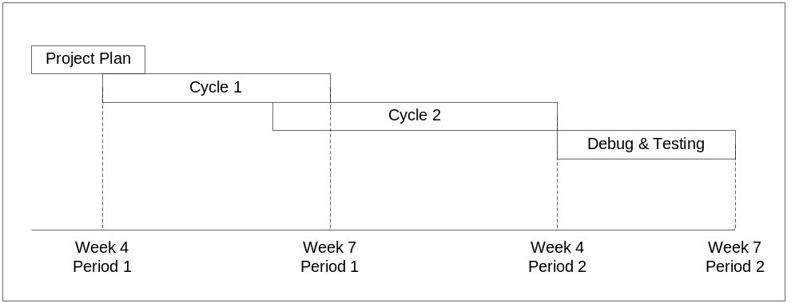

Figure 1 Initial project plan

But we did not manage to do it like that. During the development process, we encountered some problems that kept us out from track. We had to revise our project plan and we decided to extend our development cycle and end up with addition of third cycle. Unfinished jobs from cycle one were pushed to cycle two and unfinished jobs in cycle two were pushed to cycle three.

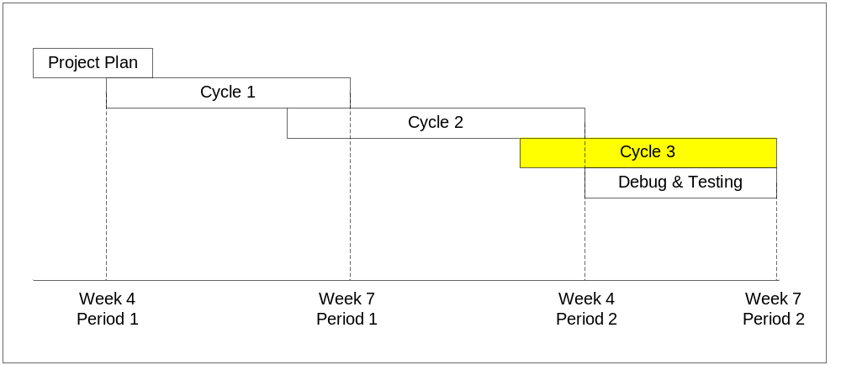

Figure 2 Extended project plan

Cycle 1

This is the first cycle of our development process. In this cycle we planned to finalize our design including general software design, database design, front end user interface design, and back end user interface design. We also planned to finish our database implementation in this cycle and then populate it with test data. Our payment method using PayPal should also be finished in this cycle. At the end of this cycle we should have our simple front end user interface implemented.

Initial Target

In general, our initial target for this cycle was to make clear all general designs about this software, to make clear what software we were going to create, define all its functionality and describe the scale of our project. We also planned to make this software works and able to handle the most simple flow where end users can browse and buy an event.
So our initial targets for this cycle were:
- Finalize design including general software design, database design, front end user interface design, and back end user interface design.
- Implement database and populate it with test data.
- Create data access layer.
- Implement simple front end user interface.
- Implement PayPal payment method.

Achieved Target

In this cycle, we managed to finish all our designs, although there were still some minor changes we should make to this initial design during the next cycle. At this point we had a clear software design and what we were going to implement next.
We also finished our database implementation and populated it with test data. The database was populated with test data intended to cover any trivial and most unexpected cases that can arise in an event database.
The database access layer was implemented using LINQ. LINQ is a static representation of the database. It provides you with a way to program database in an object oriented way and gives you the functionality of intellisense. The reason we used LINQ is that when add a new table or update the structure of the database, you only have to recompile the LINQ object and as long as you have not removed a field from the database you do not have to change the source code that uses the LINQ object.
At the end of this cycle we also had our simple front end user interface implemented. User can login and logout, they have an interface to browse events, and they can register and manage their account.
So in this cycle we managed to finish:
- Finalize design including general software design, database design, front end user interface design, and back end user interface design.
- Implement database and populate it with test data.
- Create data access layer.
- Implement simple front end user interface.

Delayed Target

We did not manage to finish all our initial targets for this cycle. At the end of this cycle, our software was still unable to handle complete flow where end user can buy an event. We did not have a shopping cart, and our payment method did not complete. There were some bugs on user interface regarding Javascript and cross-browser issue so we still had to make minor improvement on it. Our registration process also did not complete at this cycle and forced us to move all these works to cycle two.

Problem Encountered

We were too ambitious for this first cycle. We set too much target for this cycle and at the end we did not have enough time to complete all these targets. We did not expect to face a lot of technical difficulties beside non technical difficulties also. We did not expect that our database design would take a bit more time to be finalized. We did not expect that our front end user interface implementation would take more time also. We did not expect technical difficulty with PayPal payment method. As a group, we also yet need to find the best way to work together.

Cycle 2

On this second cycle, we initially had to finished all our front end user interface and back end interface. But with jobs left from cycle one, it was hard for us to complete this software in two cycles. We started to review our project plan and saw possibility to extend our development cycles in case we did not manage to finish our software in this cycle (and that was the case).

Initial Target

Our initial targets for this cycle were:
- Design all front end user interface and back end user interface.
- Implement all front end user interface and back end user interface.
- Testing and bug fixing
And in reality, we had unfinished jobs from cycle two which are:
- Finish code behind and user interface for user registration.
- Implement input validation.
- Make our current front end implementation works better.
- Implement shopping cart to enable user buy an event.
- Implement PayPal payment method.
In our first cycle, user registration with email verification was not implemented yet. So we need to finish it on this cycle.
We also decided to make global input validation functionality so it would be easier to validate input when we created another form.
Some of our front end functionalities did not work yet for example search functionality, child event on event detail page, cross-browser issue, etc. We had to finish all these functionalities.
We also had to implement our shopping cart in this cycle otherwise it would not be possible for end user to buy an event.
And of course, our PayPal payment method was still in process including our front end user interface for checkout.

Achieved Target

At the end of this cycle, we had our user registration completed. Users should verify their registration through their email. Registration for institute was also done. Institutes will request for registration first and super administrator will decide whether to approve their registration or not. Email verification for this registration was done also. Front end user interface for account management was done. All users’ data were stored in profile system.
We also had global input validation and at this point was utilized by registration form and account management form.
Our front end user interface regarding login and logout, browsing event, etc worked better at the end of this cycle. We managed to handle cross-browser issue and now our front end user interface worked on all major browsers.
At the end of this cycle we also had our shopping cart implemented and now users could browse an event and add it to their shopping cart.
So in this cycle we managed to finish:
- Code behind and front end user interface of registration including email verification.
- Input validation.
- Front end implementation worked better, solved some issues we faced before.
- Shopping cart, user could add events to their shopping cart. This shopping cart was stored in using profile system.

Delayed Target

At this point, we still missed some of our front end user interface functionality and our entire back end user interface. We also still missed our PayPal payment method.

Problem Encountered

Again, we did not expect that jobs left from cycle one would take so much time to be completed. It forced most jobs we initially planned to finish on second cycle to be moved to our unplanned cycle three. We found a better way to work together where we used our group meeting to get down to implementation and not only to discuss.

Cycle 3

As mentioned before, this cycle did not exist in our initial project plan. We added this cycle during development process because we did not manage to finish all jobs we planned to finish during cycle one and cycle two. So in this cycle, we should finish all jobs left behind.

Achieved Target

In this cycle we finished the code behind for some user controls which were not completely made dynamic in cycle two.
We also restyled the whole front end user interface and back end user interface to reduce usability issue.
For the back end user interface, we managed to create a back end interface for adding new institute, adding new administrator to the institute, editing existing registered students, deleting students, adding new events, and editing existing events.
Data access layer was modified and extended to meet the requirements of the application.
PayPal payment solution was implemented, from shopping cart page the visitors can check out and pay for the events through PayPal, and after the payment they will be redirected to our website.

Problem Encountered

We managed to get all functionalities we planned to have on our software works. We are able to finish this software although during development process we encountered some problems and delay.
If we had more time to work on this software, we would be able to make it works better and possibly adding more functionality.

